
We are looking forward to your arrival. To ensure a smooth process and you make the most of your visit please take time to read through the following information.
ARRIVAL AND PARKING
Please follow the event traffic guide (please share this with parents). Please inform us of arrival times as soon as possible. Coaches may require to unload in the bus bay in this instance we shall operate a shuttle to the centre. Car parking space is limited please lift share.
REGISTRATION
Please report to reception upon arrival to register your group and inform us of any changes to your original booking. Reception will also serve as a first aid station, please ensure your group are aware of this. You can collect additional record sheets & event maps for badge bases.
ACTIVITIES
- Activities will run from 10:00 to 16:00 on an open basis. This means session times will not be allocated, just turn up and try.
- If an activity is busy, to avoid queues please visit an alternative activity and pop back when it’s less busy.
- This is a fun, non-ticketed event. You can do whatever bases you like, whenever you like.
- Activity bases will be signposted around the site as well as on the event map, or just ask a member of our friendly staff.
- We will provide a map of where activities and badges bases will run. Due to weather it may be necessary to move bases from advertised we will try to limit this as much as possible.
- Some of the bases will be self-supervised, this will be indicated at the base.
- All activities will close for lunch between 12:15 and 12:45
- It may not be possible to complete all the requirements of the badge.
TOP TIPS!
If you are bringing a large colony, where possible try to break into smaller groups to move around the activities, this will greatly reduce waiting times. Please try and operate on a ratio of 1:6.
Please ensure the participants are dressed well for the weather, it is likely that it will be cold and wet.. Remember a packed lunch. You are welcome to bring a pop up shelter for lunch.
ADDITIONAL INFORMATION
We suggest a change of clothes, shoes and a towel (just in case)! The Auchengillan shop will operate for souvenirs and snacks. We will provide first aid and emergency facilities. Group leaders shall be responsible for their group at all times, please ensure your beavers are escorted between bases and appropriate supervision is in place. Our staff and volunteers will do all they can to ensure your stay is as comfortable as possible, pop into reception if you require any assistance throughout your stay.
PROGRAMME

08:30 – 09:30
Arrivals
Collect Welcome Packs from Reception

09:45
Welcome

10:00 – 12:15
Activities and Badges
12:15 – 12:45
Lunch
12:45 – 15:00
Activities and Badges

15:15 – 16:00
Campfire and Close

16:00 onwards
Collections




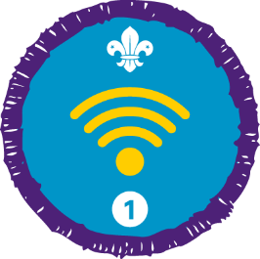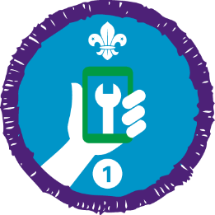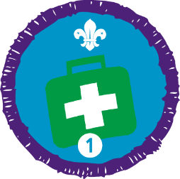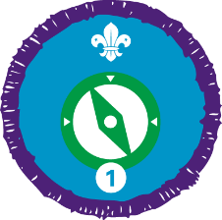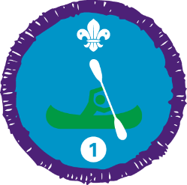
Badges tbc….
There will be a one-way system in operation from 08:30. You will be directed by event staff and we ask for your co-operation in helping us get all participants on and off site safely.

- Arrivals / Drop Off from 08:30
- Departures / Collections from 16:00.
- Entrance to the event will be via the event entrance (signposted).
- Exit will be via the event exit (signposted).
- Please park as per the diagram below.
- Participants are encouraged to lift share to help ease congestion.
- There will be no stopping or parking anywhere on the one-way system.
- Only drop offs and collections will be permitted to the drop off/collection zone.
- Please make parents aware that they must not leave their vehicle un-attended at the drop off/collection zone.
- Groups should ensure a leader is present to meet and greet the participants during the agreed drop off/collection time.
- Parents arriving out-with the agreed drop off/collection time will be re-directed to the car park.
- In the interest of group safety there will be a 5mph speed limit in place.
- No vehicles are permitted to drive on the grass.
- The drop off / collection zone needs to remain clear to accommodate the large number of coaches, this way we can try to avoid groups travelling to/from the bus bay on the road.
- Guests who do not comply with the traffic arrangements will be asked to leave site without refund.

